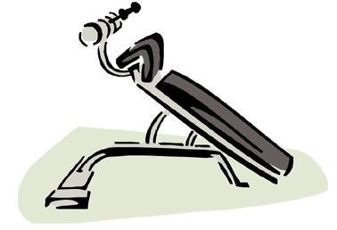

My favorite machine at the gym is the vending machine.

- Caroline Rhea